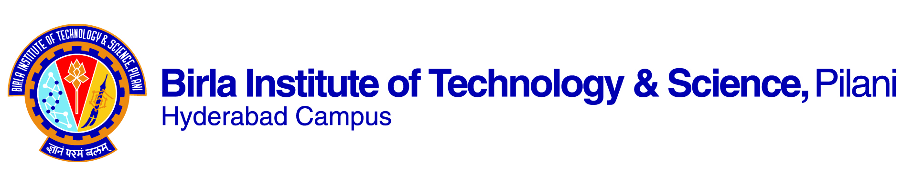

**FIRST SEMESTER 2021-2022**

**Course Handout Part II**

**Date: 20-08-2021**

In addition to part ‑I (General Handout for all courses appended to the time table) this portion gives further specific details regarding the course.

***Course No.*** : **ME F312**

***Course Title*** : **Advanced Mechanics of Solids**

***Instructor-in-charge*** : Dr.G.R.Sabareesh

**Bulletin wise contents**: Generalized Hooke’s law; Energy methods; Torsionof non-circular members; Shear center and Asymmetrical bending; Curved beams; Thick cylinders; Plates and shells; Contact stress.

1. **Scope and Objective of the Course:**

The course deals with analysis of some advanced topics in Mechanics of Solids, beyond what is covered in the basic course of Mechanics of SolidsME F 211.

1. **Course Description:**

The course work starts with **Generalized Hooke’s law** and **Three Dimensional Stress Strain Relations**. Then a detailed discussion of energy methods for solving **indeterminate problems** is included. Theory related to **non-circular** members subjected to **torsion** is treated. Theories of **Asymmetrical Bending**, **Shear Centre**, **Curved Beams** and **Thick Cylinders** are dealt with in later chapters. A chapter with a brief study on **Contact Stress**is also included.

3. **Text books:**

T1: "Advanced Mechanics of Materials" - Arthur P., Boresi and R.J. Schmidt, John Wiley, 6th Edition, 2003.

**Reference books:**

R1: “Advanced Mechanics& Solids” ‑ L.S. Srinath, Tata McGraw‑Hill Publishing Co. 2nd Edition, 2003

R2: “Advanced Mechanics of Solids” – Otto T. Bruhns, Springer Verlag, 2003

R3: “Advanced Mechanics of Materials” – R. Davis Cook and Warren C. Young, Prentice Hall 2nd Edition, 1998.

4. **Course Plan**

| **Lect. No.** | **Learning Objectives** | **Topics to be Coursed** | **Chapter in the Text Book** |
| --- | --- | --- | --- |
| 1&2 | Review of elementary Mechanics of Materials and methods of analysis, failure analysis & properties of material | Introduction & review of elementary mechanics of solids | CH1(TB) |
| 3 to 6 | Three dimensional stress strain relations and tensor representation. Generalized Hooke’s law. Hook’s law for Anisotropic elasticity, Isotropic elasticity and Orthotropic materials | Theories of stress strain & Generalized Hooke’s Law | CH2 (TB)  &  CH3 (TB) |
| 7 to 10 | Principle of potential energy, Castigliano’s theorem, Deflections in statically determinate structures and statically indeterminate structures, applications to curved beam treated as straight beams. | Energy methods and applications | CH5 (TB) |
| 11 to 16 | Torsion of Prismatic bar of circular cross section, Example problems, Saint-Venant’s Seminiverse method, Linear Elastic solutions, Torsion of Rectangular cross section members, hollow thin wall torsion members, Numerical solution of torsion problems | Non-circular members subjected to torsion | CH6 (TB) |
| 17 to 20 | Non-symmetrical loading bending and deflection of straight beams. Deflections in standard channel sections | Asymmetrical bending | CH7 (TB) |
| 21 to 25 | Shear in Thin walled beams, Shear flow in thin-walled beam cross sections,Shear center for channel sections and Shear center for composite beams. | Shear Centre | CH8 (TB) |
| 26 to 32 | Location of neutral axis, radial stress, correction of circumferential stress and deflections of curved beams. Curved beams of standard sections: I & T. Analysis of statically indeterminate curved beams (closed ring). | Curved beams | CH9 (TB) |
| 33 to 38 | Stress – Stain – Temperature relation for thick walled cylinders and composite cylinders. Analysis of open and closed cylinders | Thick walled cylinders | CH11(TB) |
| 39 to 42 | Geometry of contact surface, methods of computing contact stress, deflection of bodies in point contact and line contact with normal load. | Contact stress | CH17(TB) |

**5. Evaluation Scheme:**

|  |  |  |  |  |  |
| --- | --- | --- | --- | --- | --- |
| EC No | Evaluation Component | Duration (min.) | Weightage (%) | Date & time | Nature of component |
| 1 | Mid-Semester Test | 90 | 25 | 22/10/2021 3.30 - 5.00PM | **OB** |
| 2 | *Surprise tests | 10 | 15 | **OB** | |
| 3 | Home Assignments/Term paper |  | 20 |  | **OB** |
| 4 | Comprehensive Exam | 120 | 40 | 23/12 AN | **OB** |

**\* Surprise tutorial** tests of 10 minutes duration each will be conducted during the tutorials or regular classes and these will be evaluated for ten marks each.

**6. Chamber Consultation Hour:** To be announced in the class.

**7. Notices:**All the notices will be displayed in CMS only. Besides this, students are advised to visit regularly **CMS** (institute’s web based course management system) for latest updates.

**8. Make-up policy:**Make-up shall be given only to the genuine cases with prior intimation. No makeup is allowed for surprise tests.

**9.Academic Honesty and Integrity Policy:** Academic honesty and integrity are to be maintained by all the students throughout the semester and no type of academic dishonesty is acceptable.

**Dr.G.R.Sabareesh**

**ME F312**